Upgrade/Downgrade Account

When user clicks Upgrade Account, we need to show them the correct options based on their existing account and package_id

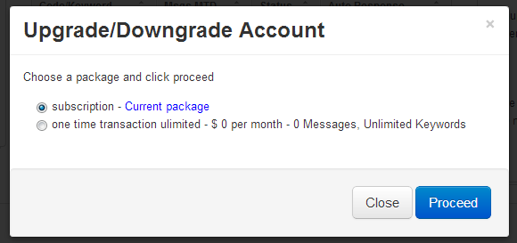

|  |  |  |
| --- | --- | --- |
| Account Type | Recurrence | Packages Shown in List |
| 1 | 1 | 1. AccountType = 1 2. Recurrence = 1 3. Active = 1 |
| 1 | 0 | 1. AccountType = 1 2. Active = 1 |

1. When the user clicks proceed, do the update_subscription API call and then take customer to confirmation screen. On the confirmation screen show the new Plan information with appropriate message.
   1. If upgrade,
      1. Your account will be upgraded to the following package.
      2. Show package information.
   2. If downgrade
      1. Your account will be adjusted to the following package.
      2. Show package information.

Recurly give you the option when doing update_subscription to set the effective date for a) immediate or b)at next renewal. If it is an upgrade, I want to set time as immediate and if downgrade set time as at next renewal.

**Upgrades**

Typically in an upgrade scenario, a subscriber is moving to a more expensive plan and you would like to receive the money immediately. In this scenario, you would send a *change subscription request* to Recurly and specify that the **timeframe** is **now**. Recurly will perform the necessary prorations to upgrade the subscriber immediately.

**EXAMPLE**

As an example, let’s say the user is on a $10/mo. plan and moves to a $20/mo. subscription halfway through the month. Recurly will create a $5 credit for the current subscription and a $10 charge for the new subscription, thus billing the user $5 for the upgrade. When the subscription renews at the end of the month, it will renew at $20

________________________________________________________________________________________

On Upgrades, we want to set the time frame to immediate.

When we receive the Update_Subscription_Notification on an **Upgrade**, there will also be a successful_payment or payment_failure notification because of the difference in price.

1. If you get Update_Subscription and Successful_Payment
   1. Update PlanId in Accounts table
   2. Add Pro-rate Plan Credits
      1. Previous package plan credits – current balance plan credits = plan credits used month to date
      2. New package plan credits – plan credits month to date = pro-rated plan credits
      3. Leave Rollover Credits alone
   3. Send UpdateConfirmation Email
      1. New node in Content_Email.xml
         1. <UpgradeConfirmation>
         2. <subject>SNDMobile Plan Upgrade Confirmation</subject>
         3. <message>Your plan has been upgraded</message>

**Downgrades**

On Downgrades, we want to set the time frame to “at renewal”.

**Note: Recurly documentation is not clear on exactly which PN’s are sent with a downgrade and when. I will have to ask their tech support and get back to you**

When we receive the Update_Subscription_Notification on an **Downgrade**, there will also be a successful_payment or payment_failure notification because of the difference in price.

1. If you get Update_Subscription and Successful_Payment
   1. Update PlanId in Accounts table
   2. Do Rollover adjustment
   3. Update Plan Credits according to new Package
   4. Send DowngradeConfirmation Email
   5. New node in Content_Email.xml
      1. <DowngradeConfirmation>
      2. <subject>SNDMobile Plan Adjustment Confirmation</subject>
      3. <message>Your plan has been adjusted</message>

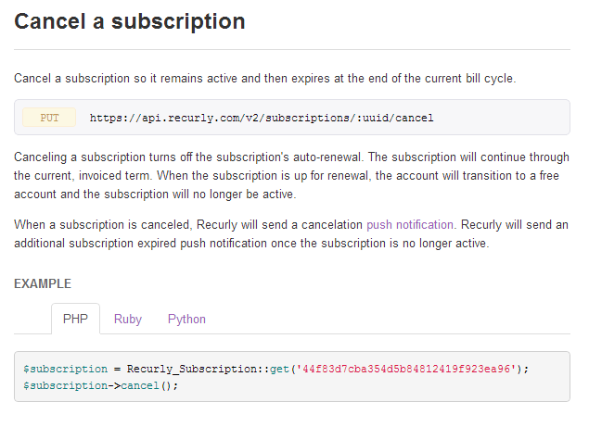

1. Add a new field to Account table
   1. PendingCancel, tiny int, default 0
2. When user clicks cancel account,
   1. Do cancel_subscription api call
   2. Set PendingCancel=true in accounts table
   3. Show **cancel_confirmation_ text**
3. You will receive a PN for the cancel at the time of the cancel request
4. When you receive a PN for ExpiredAccount when the account expires at end of cycle
   1. Set status to 0 in Account table
   2. Set PendingCancel in Account table to false
   3. Send AccountCanceled email
      1. Add new node to Content_Email.xml
         1. <AccountCanceled>
         2. <subject>SNDMobile Account Canceled</subject>
         3. <message>Your SNDMobile account is now officially canceled.</message>